Let’s Go Fishing Thank You Card Tutorial
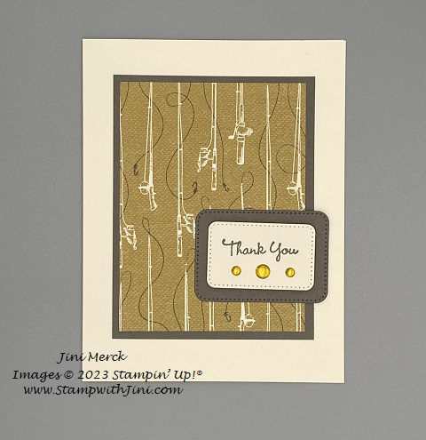

Paper
Very Vanilla Thick Card stock: Cut 5 ½" x 8 ½"; scored at 4 ¼"
Pebbled Path Card stock: Cut 3 1/4" x 4 1/4"
Let’s Go Fishing Designer Series Paper: Cut 3" x 4"
Pebbled Path Card stock: Cut 2 1/2" x 1 3/4"
Very Vanilla Card stock: Cut 2 1/2" x 1 3/4"
2023-2025 In Color Dots (Wild Wheat): 2 small and 1 large

Supplies:

Stamps
Go To Greetings (158763)

Paper
Let’s Go Fishing Designer Series Paper (161534)
Pebbled Path Card stock (161722)
Very Vanilla Thick Card stock (101650)
Very Vanilla Card stock (101650)

Ink
Pebbled Path Classic Ink (161648/161653)

Accessories
Nested Essentials Dies (161597)
2023-2025 In Color Dots (161620)
Take Your Pick Tool (144107/150006)

Adhesives
Stampin’ Seal (149699/152812)
Stampin’ Dimensionals (104430)

Jini Merck, Stampin’ Up! Demonstrator 706 754-7124 StampwithJini@gmail.com
www.StampwithJini.com www.JiniMerck.stampinup.net © 2023 Jini Merck

Let’s Go Fishing Thank You Card Tutorial
YouTube Video Link: https://youtu.be/NzxaJ3UUCQU

Assembly:

- Stamp the sentiment onto Very Vanilla Card stock using Pebbled Path Classic Ink.
- Cut the sentiment out using the Nested Essentials Die and your Stampin’ Cut & Emboss.
- Cut a coordinating label shape using the Pebbled Path card stock and the Stampin’ Cut and Emboss.
- Adhere the Let’s Go Fishing Designer Series Paper to the Pebbled Path panel.
- Adhere the layered panel to the card front.
- Adhere the Pebbled Path label in the bottom right of the card front as shown.
- Add Stampin’ Dimensionals to the back of the sentiment and adhere to the Pebbled Path layer.
- Add 3 of the In Color Dots using your Take Your Pick Tool below the sentiment.
- Stamp the inside sentiment panel using Pebbled Path Classic Ink if desired.
- Decorate your Very Vanilla Envelope as desired.

Jini Merck, Stampin’ Up! Demonstrator 706 754-7124 StampwithJini@gmail.com
www.StampwithJini.com www.JiniMerck.stampinup.net © 2023 Jini Merck

