Let’s Go Fishing Thinking of You Card Tutorial
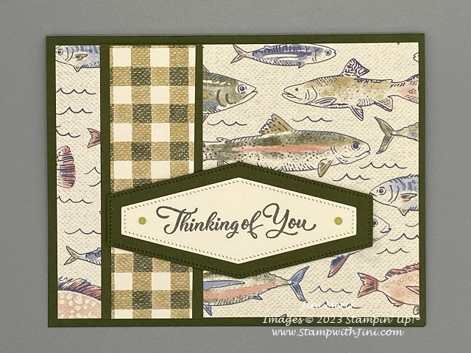

Paper
Mossy Meadow Card stock: Cut 5 ½" x 8 ½"; scored at 4 ¼"
Let’s Go Fishing Designer Series Paper: Cut 5 1/4" x 4"
Mossy Meadow Card stock: Cut 1 1/2" x 4"
Let’s Go Fishing Designer Series Paper: Cut 1 1/4" x 4"
Mossy Meadow Card stock: Cut 2 1/2" x 3"
Very Vanilla Card stock: Cut 2 1/2" x 3"
Very Vanilla Card stock: Cut 5 1/4" x 4"
Ombre Matte Decorative Dots (Old Olive): 2 small

Supplies:

Stamps
Go To Greetings (158763)

Paper
Let’s Go Fishing Designer Series Paper (161534)
Mossy Meadow Card stock (133676)
Very Vanilla Card stock (101650)

Ink
Pebbled Path Classic Ink (161648/161653)

Accessories
Nested Essentials Dies (161597)
Ombre Matte Decorative Dots (161448)
Take Your Pick Tool (144107/150006)

Adhesives
Stampin’ Seal (149699/152812)
Stampin’ Dimensionals (104430)

Jini Merck, Stampin’ Up! Demonstrator 706 754-7124 StampwithJini@gmail.com
www.StampwithJini.com www.JiniMerck.stampinup.net © 2023 Jini Merck

Let’s Go Fishing Thinking of You Card Tutorial
YouTube Video Link: https://youtu.be/vDWLI-se6vA

Assembly:

- Stamp the sentiment onto Very Vanilla Card stock using Pebbled Path Classic Ink.
- Cut the sentiment out using the Nested Essentials Die and your Stampin’ Cut & Emboss.
- Cut a coordinating label shape using the Mossy Meadow card stock and the Stampin’ Cut and Emboss.
- Adhere Let’s Go Fishing Designer Series Paper to the card front.
- Adhere the strip of Let’s Go Fishing Designer Series Paper to the strip of the Mossy Meadow Card stock.
- Adhere layered Designer Series Paper to the left side of the card front about ¾ inches from the edge.
- Adhere the sentiment to the Mossy Meadow Label.
- Add 2 of the Ombre Matte Dots using your Take Your Pick Tool to the right and left-ends of the sentiment panel.
- Stamp the inside sentiment panel using Pebbled Path Classic Ink if desired.
- Adhere the inside stamped panel to the inside of the card.
- Decorate your Very Vanilla Envelope as desired.

Jini Merck, Stampin’ Up! Demonstrator 706 754-7124 StampwithJini@gmail.com
www.StampwithJini.com www.JiniMerck.stampinup.net © 2023 Jini Merck

