Meandering Meadow Desk Calendar Tutorial

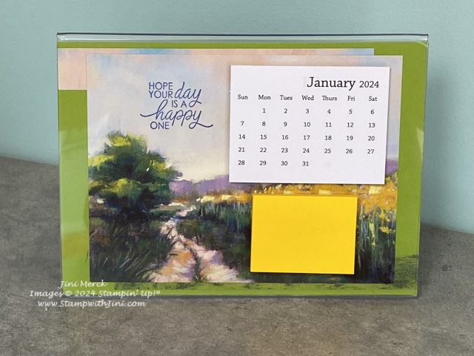

Paper
Granny Apple Green Card stock: Cut 7" x 5"
Meandering Meadow Designer Series Paper: Cut 4 1/2" x 6"
Meandering Meadow Designer Series Paper: Cut (2) 6" x ¾"
Acrylic Frame: 1
Mini Calendar: 1
Post it Note: 1

Supplies:

Stamps
So Sincere (162283)

Paper
Meandering Meadow Designer Series Paper (Online Exclusive 162735)
Granny Apple Green Card stock (146990)

Ink
Orchid Oasis Classic Ink (159214/159215)

Jini Merck, Stampin’ Up! Demonstrator 706 754-7124 StampwithJini@gmail.com
www.StampwithJini.com www.JiniMerck.stampinup.net © 2024 Jini Merck

Adhesives
Snail (104332/104331)
Tear & Tape (154031)

Other
7" x 5" Acrylic Frame
3 x 2" Mini Calendar
2" x 1 ½" Post It Notes

Meandering Meadow Desk Calendar Tutorial
Video Tutorial YouTube Link: https://youtu.be/a6FR_OMh2S4

Assembly:

- Cut the top of the Designer Series Paper to give you the two pieces at the 4 ½" mark.
- Then cut the smaller piece to create 2 pieces that are ¾" x 6"
- Adhere the ¾" strips at the top of the Granny Apple Green Card stock lining it up on the left-hand edge.
- Adhere the second ¾" strip to the bottom of the Granny Apple Green Card stock lining it up on the right-hand edge.
- Stamp the sentiment using the Orchid Oasis Classic Ink in the sky on the left-hand side as shown.
- Adhere the stamped panel onto the center of the Granny Apple Green panel.
- Slip the finished panel into the acrylic frame.
- Using Tear & Tape adhere the calendar onto the top right-hand side of the frame as desired.
- Then add the post it notes below the calendar using Tear & Tape.

Cut Designer Series Paper pieces:

Cut 6 x 3/4
Cut 6 x 3/4

Cut 6 x 4 1/2

Jini Merck, Stampin’ Up! Demonstrator 706 754-7124 StampwithJini@gmail.com
www.StampwithJini.com www.JiniMerck.stampinup.net © 2024 Jini Merck

